

COURSE: CSC262 – INTRODUCTION TO ARTIFICIAL INTELLIGENCE
SMART INTERVIEW PREPARATION EXPERT SYSTEM
An AI-Powered Interview Readiness Analyzer Using
Prolog Knowledge Representation & Backward Chaining

Group # 09
Muhammad Nafay Anjum (FA24-BCS-078)
Sidra Tul Muntaha (FA24-BCS-097)

SUBMITTED TO: Ms. Farah Saeed
SUBMISSION DATE: 17th May 2026
Sr. No. | Contents | Page No.
1 | Abstract | 3
2 | Introduction | 4
3 | Proposed System | 4
4 | Advantages/Benefits of Proposed System | 5
5 | Objectives | 5
6 | Scope | 6
6.1 | In-Scope Features | 6
6.2 | Out-of-Scope Features | 7
7 | System Flow | 8
8 | Modules | 9
8.1 | Module 1: Prolog Knowledge Base and Inference Engine | 9
8.2 | Module 2: Skill Gap Analysis Module | 10
8.3 | Module 3: Readiness Scoring & Rule-Based Reasoning Module | 11
8.4 | Module 4: Explainable AI (XAI) & Recommendation Module | 12
8.5 | Module 5: Mock Interview & User Interface Layer | 13
9 | Methodology | 14
9.1 | Phase 1 — Input Collection | 14
9.2 | Phase 2 — Skill Gap Analysis (Prolog Backward Chaining) | 14
9.3 | Phase 3 — Rule-Based Scoring | 15
9.4 | Phase 4 — Recommendations & Explanation | 15
9.5 | Phase 5 — Mock Interview | 15
10 | System Limitations/Constraints | 16
11 | Tools and Technologies | 16
12 | Conclusion | 17
13 | References | 18

SMART INTERVIEW PREPARATION EXPERT SYSTEM
An AI-Powered Interview Readiness Analyzer Using
Prolog Knowledge Representation & Backward Chaining

Abstract
The Smart Interview Preparation Expert System is an AI-driven tool designed to evaluate technical readiness for job seekers. It utilizes SWI-Prolog as a symbolic reasoning engine to implement core AI techniques including Knowledge Representation, Backward Chaining, Unification, and Rule-Based Reasoning.
By analyzing user-provided skills, confidence, and experience, the system identifies skill gaps via negation-as-failure and calculates a weighted readiness score. The application features an Explainable AI (XAI) module for transparent feedback and an interactive mock interview component with keyword evaluation. Built using a Python-Prolog hybrid architecture (PySwip) and a Streamlit interface, this project demonstrates the practical utility of logic programming in career development.

1. Introduction
Technical interview preparation is often fragmented and overwhelming. Candidates frequently struggle to identify specific skill gaps for target roles or lack objective feedback on their readiness. Existing platforms provide generic content but fail to offer personalized, logic-based analysis. This project acts as a virtual career consultant, encoding domain expertise into a Prolog Knowledge Base. Using backward chaining, the system reasons through user profiles to provide tailored study roadmaps, bridging the gap between theoretical AI concepts and real-world software solutions.

2. Proposed System
The proposed system follows a classic Expert System Architecture:
- Knowledge Base (KB): A Prolog file (knowledge_base.pl) storing facts about roles, skills, importance weights, and expert recommendations.
- Inference Engine: Powered by SWI-Prolog, it uses backward chaining to identify gaps and rule-based logic to calculate weighted scores.
- User Interface: A modern Streamlit dashboard for data input and visual feedback.
- Explanation Facility: A module that justifies the AI’s decisions, enhancing transparency.
The Python-Prolog bridge is managed via PySwip, allowing the application to combine Prolog’s logical rigor with Python’s UI capabilities.

3. Advantages/Benefits of Proposed System
Advantage / Benefit | Description
Personalized Role-Specific Analysis | Unlike generic platforms, the system tailors its entire analysis to the user's specific target role. Each role has unique skill requirements, weights, and recommendations in the Prolog knowledge base.
Transparent Explainable AI | The system explains WHY it made each recommendation through four natural-language explanations covering skill gaps, confidence impact, experience influence, and score interpretation.
Weighted Multi-Factor Scoring | The readiness score uses Prolog rules to apply different weights (high=30, medium=20) to skills based on importance, plus confidence and experience bonuses, producing a meaningful score.
Interactive Mock Interview | Provides hands-on practice with role-specific technical and HR questions. Keyword-based evaluation gives immediate scoring and identifies missing concepts.
Modular Extensible Architecture | New roles, skills, and recommendations can be added by editing the Prolog `.pl` file alone — no Python code changes required.
Practical AI Demonstration | Demonstrates seven AI concepts from CSC262: Knowledge Representation, Backward Chaining, Unification, Rule-Based Reasoning, Expert System, Explainable AI, and Negation-as-Failure.

Objectives
- Build an AI expert system using Prolog for knowledge representation and backward chaining inference.
- Identify skill gaps for specific job roles by comparing user skills against role requirements.
- Compute a weighted interview readiness score using rule-based reasoning in Prolog.
- Generate personalized study recommendations through Prolog unification.
- Provide an interactive mock interview module with keyword-based answer evaluation.
- Build a modern, dark-themed web interface using Python Streamlit.

4. Scope
In-Scope Features:
The following functionalities are included in the scope of this project:
Prolog Knowledge Base
- Stores domain knowledge as Prolog facts and rules
- Supports 4 job roles with 5 skills each
- Includes skill importance weights (high, medium, low)
- Contains role-specific preparation recommendations

Skill Gap Analysis (Backward Chaining)
- Identifies missing skills using Prolog backward chaining
- Uses negation-as-failure (`\+ member`) to detect gaps
- Classifies gaps as high-priority or medium-priority

Readiness Score Calculation (Rule-Based Reasoning)
- Computes weighted score (0–100) using Prolog rules
- Considers skill weights, confidence bonuses, experience bonuses
- Classifies score into categories (Interview Ready, Almost Ready, etc.)

Personalized Recommendations (Unification)
- Matches weak skills with expert advice through Prolog unification
- Provides role-specific and skill-specific preparation guidance
Explainable AI Module
- Generates four natural-language explanations per assessment
- Covers skill gaps, confidence impact, experience influence, score interpretation

Mock Interview Module
- Technical and HR questions stored in JSON
- Keyword-based answer evaluation with scoring
- Progress tracking and color-coded feedback

Web Interface
- Four-page Streamlit dashboard (Home, Assessment, Results, Mock Interview)
- Dark-themed UI with custom CSS styling
- Session-based state management

Out-of-Scope Features:
The following features are not included in this project:
- Machine learning or deep learning (purely symbolic AI)
- Natural language processing beyond keyword matching
- Integration with external job posting APIs
- User account management or persistent data storage
- Mobile application development
- Real-time collaborative features

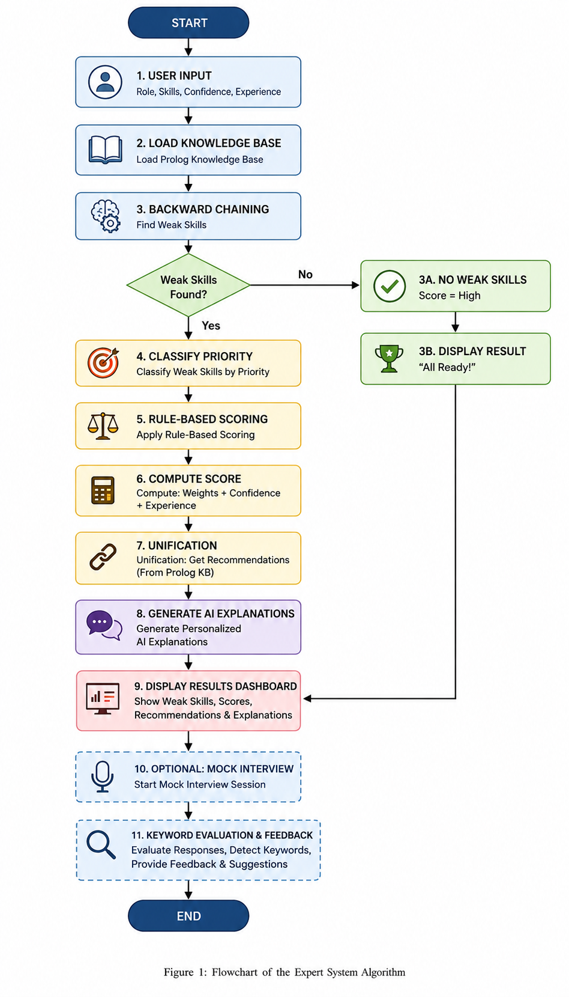
SYSTEM FLOW:

5. Modules
The Smart Interview Preparation Expert System is built on a modular architecture that separates symbolic logic from the presentation layer. Each module handles a specific part of the system, working together to analyze skills, generate results, and provide an interactive experience.

5.1 Module 1: Prolog Knowledge Base and Inference Engine (knowledge_base.pl + prolog_engine.py)
This module is the core AI "brain" of the system, responsible for all interview analysis, scoring, and recommendation logic using SWI-Prolog.
- Main Responsibilities:
  - Store job roles, required skills, and importance weights as Prolog facts.
  - Identify missing skills using Backward Chaining and Negation-as-Failure.
  - Execute rule-based reasoning to calculate readiness scores and category mapping.
  - Perform Unification to retrieve personalized study recommendations.

- AI Techniques Implemented:
  - Backward Chaining: Logic starts from a goal (e.g., "Is the user ready?") and works back to verify facts.
  - Negation-as-Failure: Gaps are detected when a required skill cannot be proven to exist in the user's profile (\+ member).
  - Rule-Based Reasoning: A complex set of IF-THEN rules handles scoring bonuses and readiness thresholds.

- Technical Integration:
  - Uses PySwip to bridge Python data into the Prolog environment.
  - Includes alternative career suggestion logic based on the user's existing skill set.
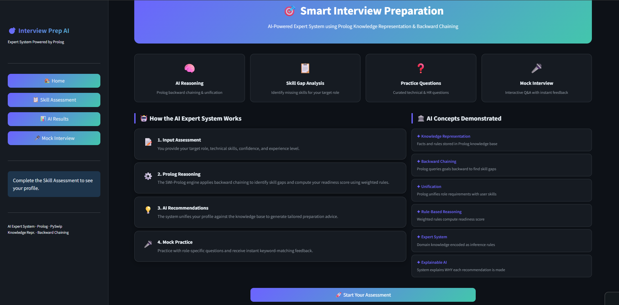

5.2 Module 2: Skill Gap Analysis Module
This module identifies the difference between a user's current profile and their target career path.
- Gap Detection: Uses the inference engine to cross-reference user skills against role requirements.
- Dynamic Fact Injection: Python captures user inputs from the UI and asserts them as temporary facts into Prolog for real-time analysis.
- Priority Classification: Automatically tags missing skills as "High Priority" (critical for the role) or "Medium Priority" based on the weights defined in the Knowledge Base.
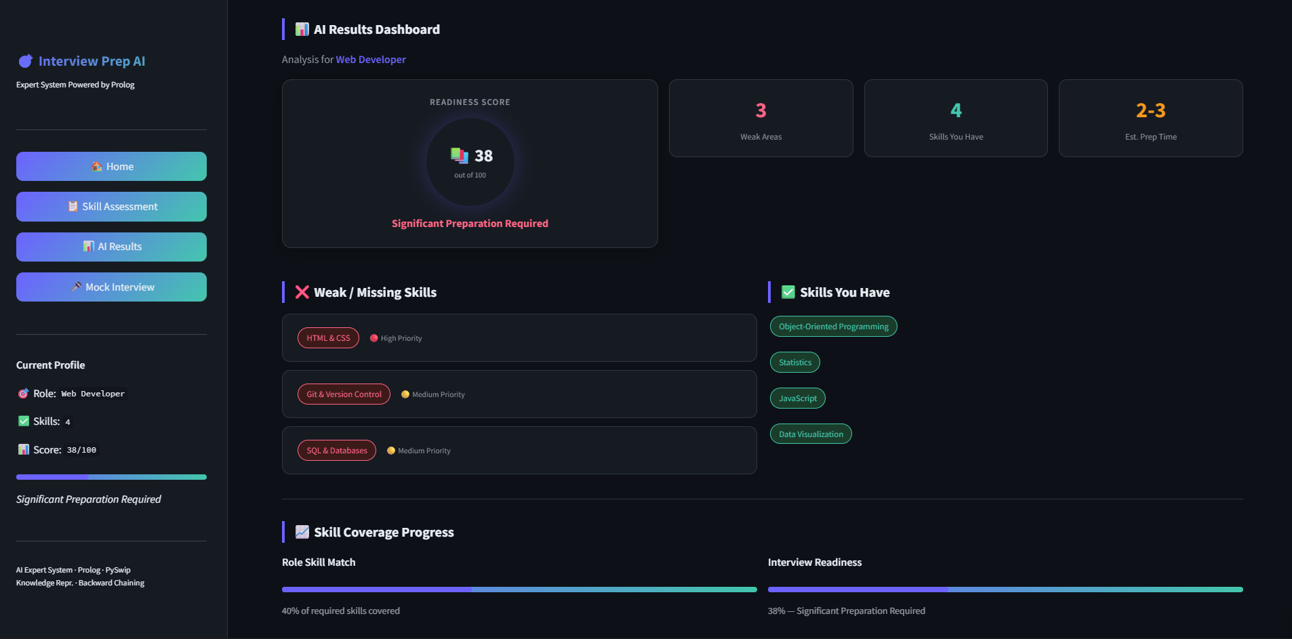

5.3 Module 3: Readiness Scoring & Rule-Based Reasoning Module
This module converts logical facts into a quantifiable readiness metric (0–100%).
- Weighted Calculation: Assigns variable points based on skill importance (e.g., High-weight skills like DSA grant 30 points).
- Multi-Factor Scaling: Implements rules to scale the base skill score to 80% of the total available points.
- Bonus Logic: Adds up to 20 additional points based on self-reported confidence levels and years of professional experience.
- Category Mapping: Uses the Prolog Cut Operator (!) to classify users into readiness tiers: "Interview Ready," "Almost Ready," or "Needs Preparation."

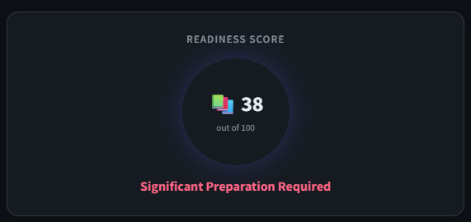
5.4 Module 4: Explainable AI (XAI) & Recommendation Module
This module provides transparency to the AI's decision-making process.
- Transparency Layer: Generates four distinct natural-language explanations (Gap analysis, Confidence impact, Experience impact, and Score interpretation).
- Unification-Based Retrieval: Uses Prolog variables to match specific missing skills with their corresponding expert preparation advice stored in the KB.
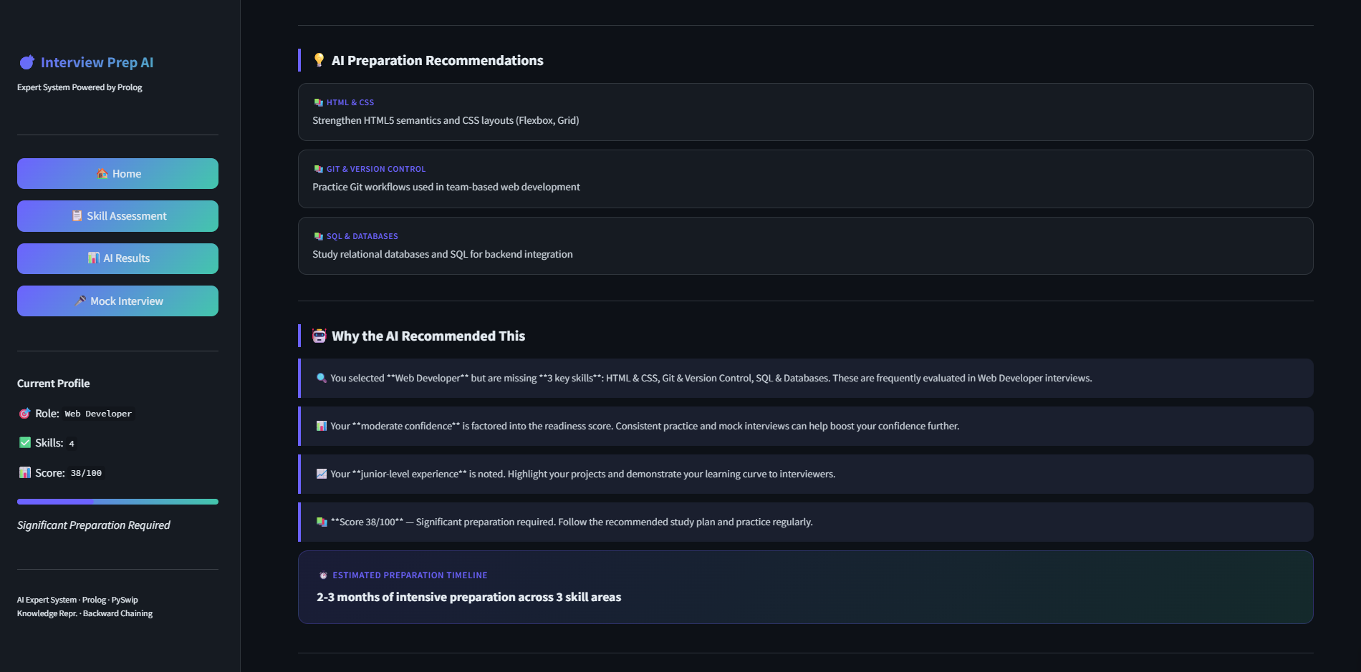
- Actionable Advice: Displays recommendation cards that explain why the AI flagged a specific weakness and how the user should study it.
5.5 Module 5: Mock Interview & User Interface Layer (app.py + question_bank.py)
This module manages the visual appearance, user interaction, and the interactive mock interview experience.
- Streamlit Interface: A modern dark-themed dashboard featuring sidebar navigation, CSS-styled gradient cards, and a custom score ring.
- Intelligent Mock Interview:
  - Targeted Questioning: Specifically prioritizes interview questions related to the user's identified weak skills.
  - Keyword Evaluation: A Python algorithm matches user text answers against "Expected Concepts" defined in the questions.json bank.
- Interactive Flow: Includes progress tracking for the interview, "Submit/Skip" functionality, and a final summary report with color-coded feedback.
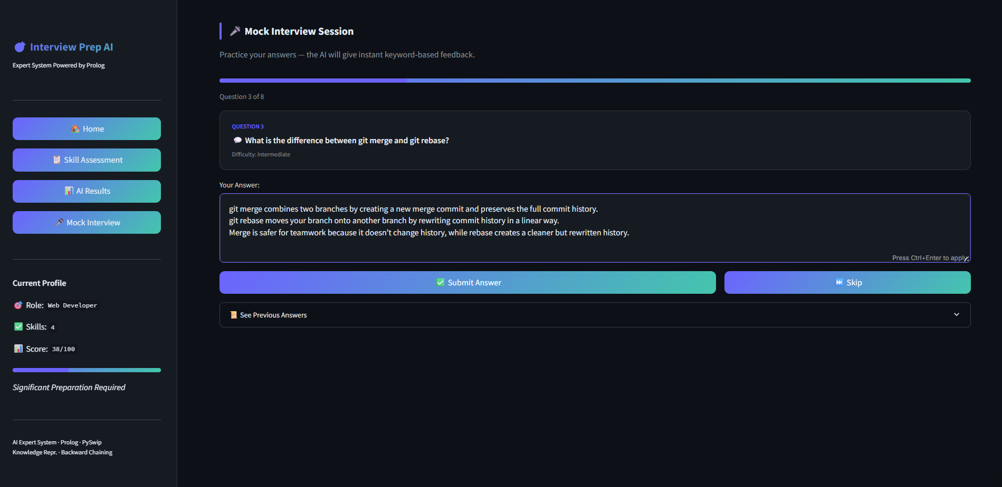

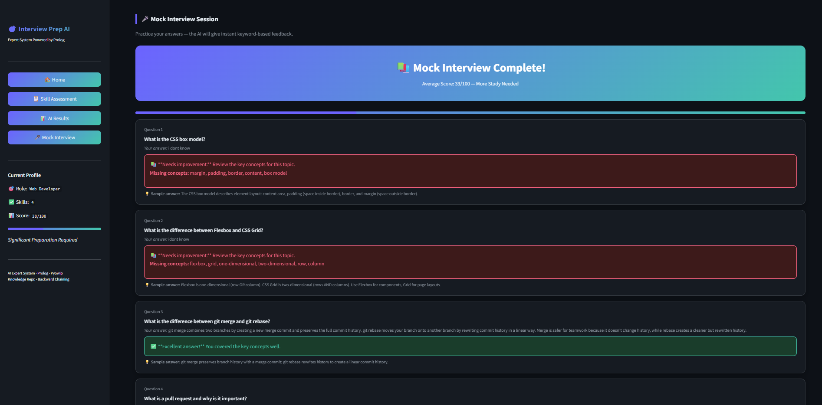

Methodology
The expert system uses a multi-phase hybrid approach:
Phase 1 — Input Collection
- User selects a target role from four options: Software Engineer, Web Developer, Data Analyst, or UI/UX Designer
- User selects their current skills from a list of 13 skills
- User selects confidence level (High, Medium, Low) and experience level (Senior, Mid, Junior, Fresher)

Phase 2 — Skill Gap Analysis (Prolog Backward Chaining)
- Python sends a query to SWI-Prolog: weak_skills(Role, UserSkills, WeakSkills)
- Prolog uses is_weak_skill/3 to check missing required skills
- Negation-as-failure (\+ member(Skill, UserSkills)) identifies skills the user does not have
- findall/3 collects all weak skills into a complete list

Phase 3 — Rule-Based Scoring
- Prolog calculates total required skill points for the selected role
- It calculates earned points based on the user’s known skills
- Base score is computed using BaseScore = (Earned × 80) / Total
- Confidence adds 0–10 bonus points
- Experience adds 0–10 bonus points
- Final score is capped at 100 and categorized into levels (e.g., Ready, Moderate, Needs Improvement)

Phase 4 — Recommendations & Explanation
- Prolog matches each weak skill with its corresponding recommendation rule
- Python converts results into simple explanations in natural language
- All results are displayed on a dashboard in a structured format

Phase 5 — Mock Interview
- Interview questions are selected based on weak skills and HR topics
- The system conducts 8 questions one by one
- User answers each question
- Keyword-based matching is used to evaluate answers and generate feedback

6. System Limitations/Constraints
No. | Limitation / Constraint | Description
1 | Limited Role Coverage | Only 4 job roles with 5 skills each. Adding new roles requires manual Prolog editing.
2 | Keyword-Based Evaluation | Mock interview uses keyword matching, not NLP. Well-reasoned answers using different terms may score lower.
3 | No Persistent Storage | All data is in session state and lost when browser closes. No user accounts or history.
4 | Requires SWI-Prolog | PySwip requires SWI-Prolog installed locally, limiting deployment environments.
5 | No Adaptive Learning | The system does not learn from user interactions or improve recommendations over time.

7. Tools and Technologies
Category | Tool / Technology | Version | Rationale
IDE | Visual Studio Code | 1.96+ | Lightweight editor with Python and Prolog extensions
Programming Language | Python | 3.10+ | Main language for UI, bridge logic, and data handling
AI Engine | SWI-Prolog | 9.x | Logic programming for knowledge representation and backward chaining
Library | PySwip | 0.2.11+ | Enables Python to instantiate and query SWI-Prolog directly
Framework | Streamlit | 1.30+ | Rapid web application framework for interactive dashboard
Data Format | JSON | — | Storing interview questions with keywords and sample answers
AI Technique | Backward Chaining | — | Goal-driven reasoning from query to supporting facts in Prolog
AI Technique | Unification | — | Automatic variable binding to make Prolog queries succeed
AI Technique | Rule-Based Reasoning | — | Weighted IF-THEN rules for computing readiness scores
AI Technique | Negation-as-Failure | — | Closed-world assumption: unprovable = false

8. Conclusion
The Smart Interview Preparation Expert System successfully bridges the gap between symbolic AI theory and practical application. By integrating Python and Prolog, the system applies core CSC262 concepts—specifically Backward Chaining, Unification, and Negation-as-Failure—to provide personalized career guidance. Its modular architecture ensures a clean separation between domain expertise (Prolog) and user interaction (Streamlit), allowing for easy scalability. Ultimately, this project demonstrates how logic programming can create transparent, explainable, and valuable AI tools for the modern job market.

9. References
- Russell, S., & Norvig, P. (2020). Artificial Intelligence: A Modern Approach (4th ed.). Pearson.
- Bratko, I. (2012). Prolog Programming for Artificial Intelligence (4th ed.). Pearson Education.
- CSC262 Materials (2026). Introduction to AI Lecture Slides & Lab Manuals. CUI Department of Computer Science.
- SWI-Prolog Documentation (2026). https://www.swi-prolog.org
- Streamlit Documentation (2026). https://docs.streamlit.io
- PySwip Documentation (2026). https://github.com/yuce/pyswip
- Giarratano, J., & Riley, G. (2005). Expert Systems: Principles and Programming. Thomson.

